**MULTIMEDIA AND ANIMATION LAB**

**PROJECT NAME**

**JNTU-GV College**

**TEAM MEMBERS**

B.Naga Kavya Sri(20VV1A1209)

B.Sai Kiran(20VV1A1211)

D.Mohanaa Vishnu Priya(20VV1A1213)

G.Siva Rama Krishna(20VV1A1215)

M.S.S.P.Anuraag (20VV1A1238)

P.Dileep Kumar (20VV1A1251)

R.Sangeetha(20VV1A1255)

**ABOUT OUR PROJECT**

This project is animating the JNTU-GV University of engineering ,Vizianagaram.The JNTUK University College of Engineering Vizianagaram has been established during September 2007.It is beautifully constructed on a top of a small hill. Infrastructure is well developed ,it also has a very good view of the whole town. The JNTU-GV College was chosen to animate to show it’s beauty of Infrastructure.To portrait the same beauty into anime we used Blender.

**Software**

**BLENDER**



Blender is the free and open source 3D creation suite. It supports the entirety of the 3D pipeline—modeling, rigging, animation, simulation, rendering, compositing and motion tracking, even video editing and game creation. Advanced users employ Blender’s API for Python scripting to customize the application and write specialized tools; often these are included in Blender’s future releases. Blender is well suited to individuals and small studios who benefit from its unified pipeline and responsive development process.

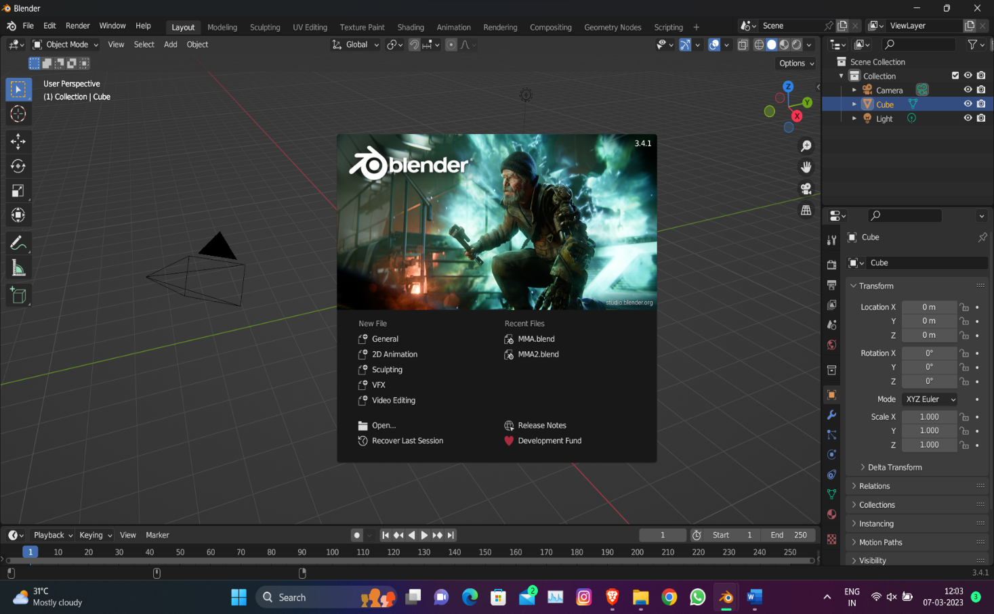

Using Blender we started constructing the following:

* Firstly ,started studying the layout of the college.
* 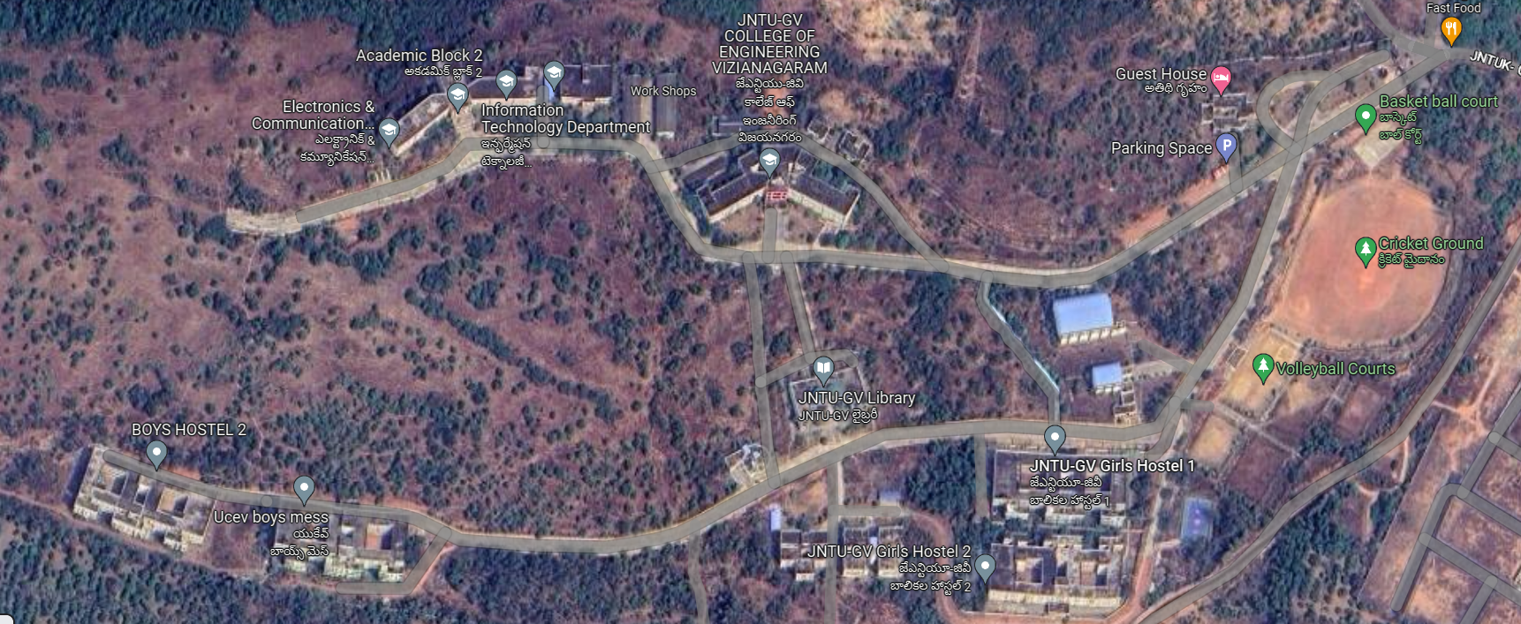Later constructed the landscape similar to realworld.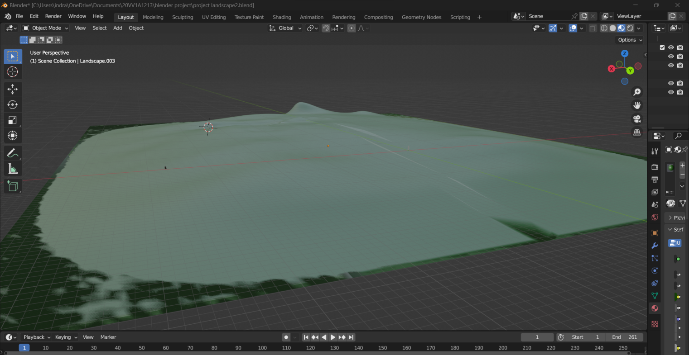
* Started working by making a list of infrastructure present in the college
* Began building up every single exterior framework that is situated

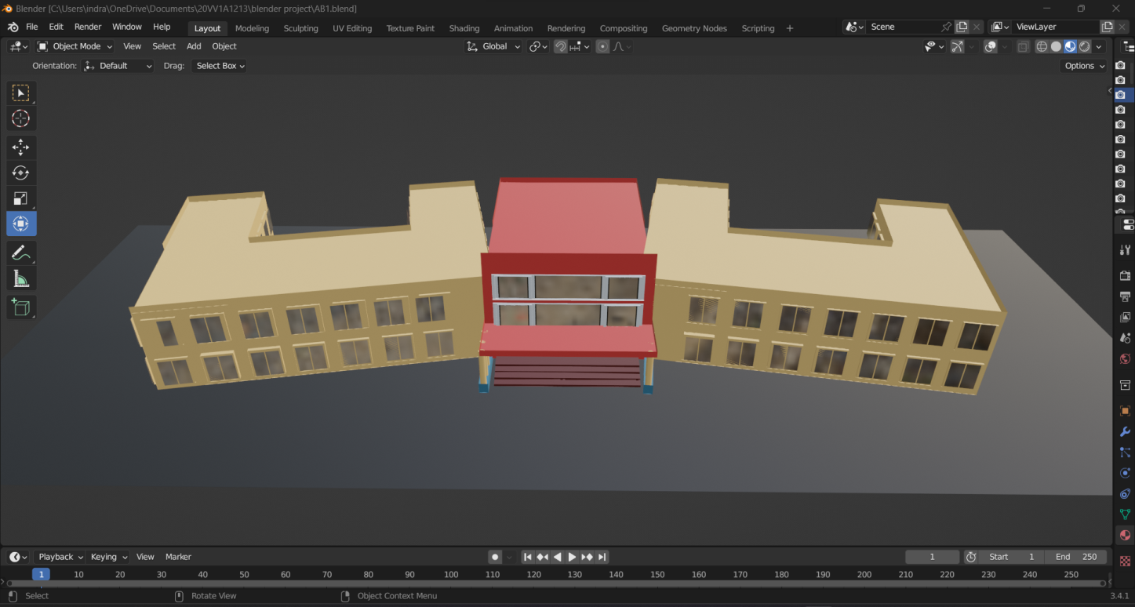

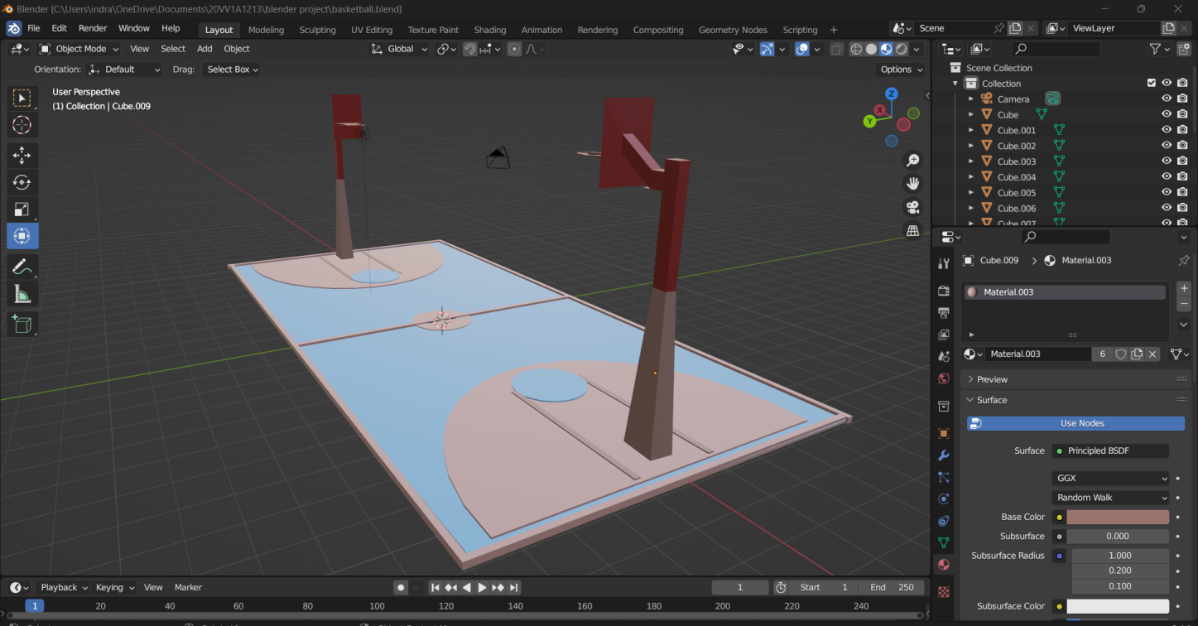

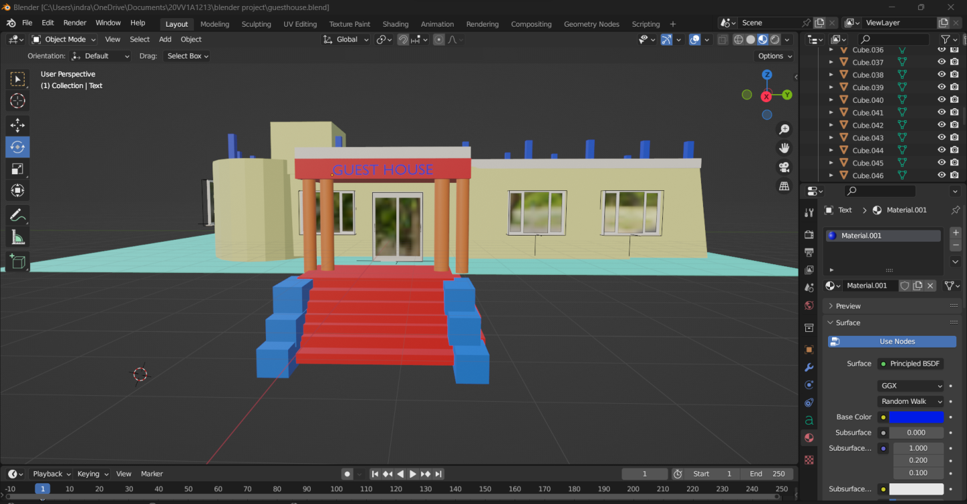

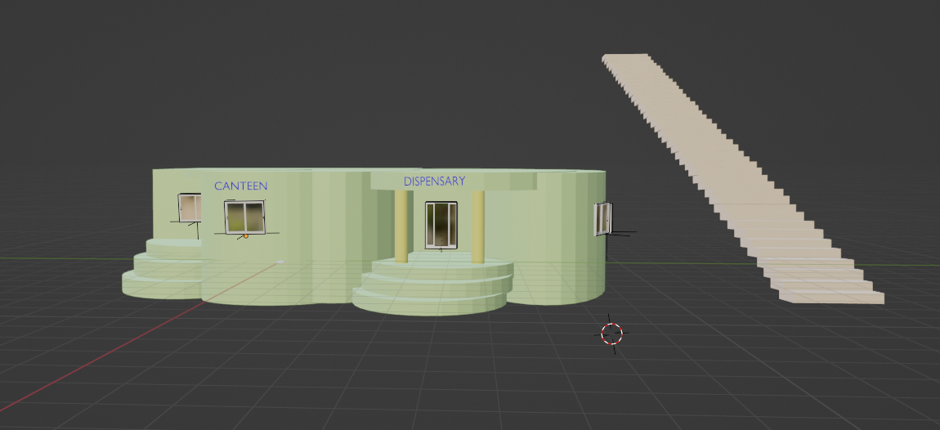

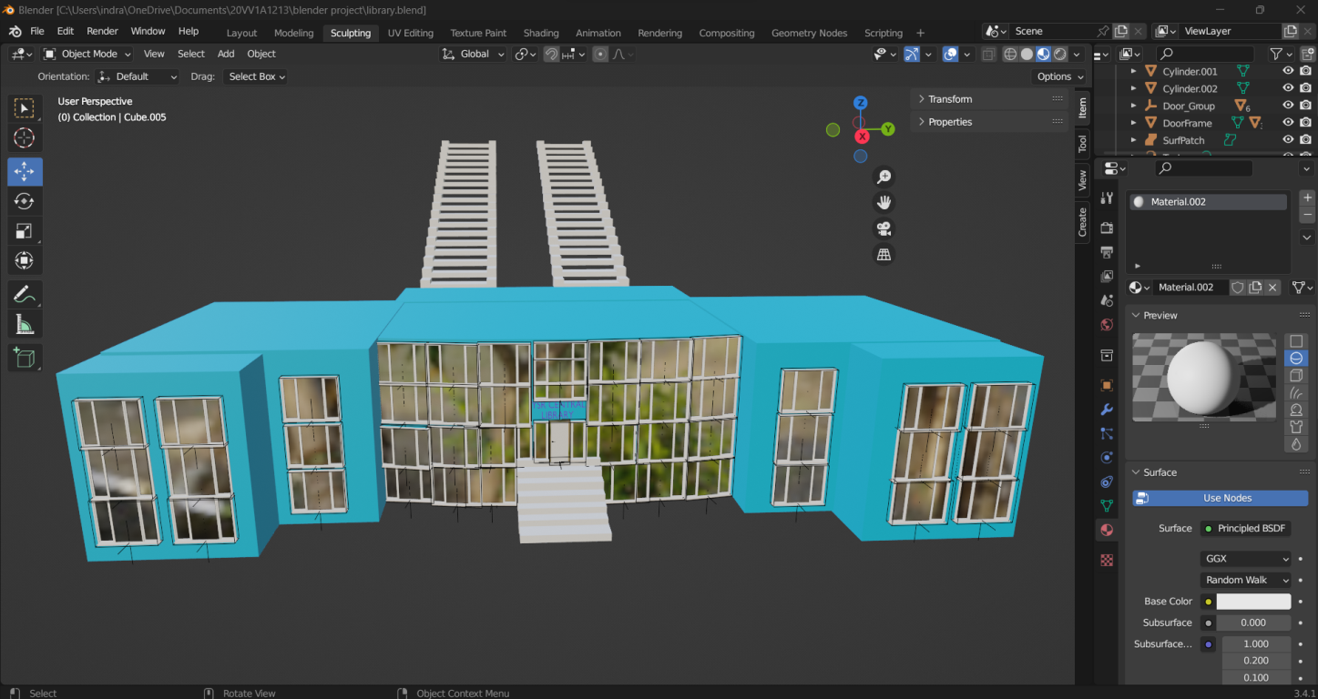

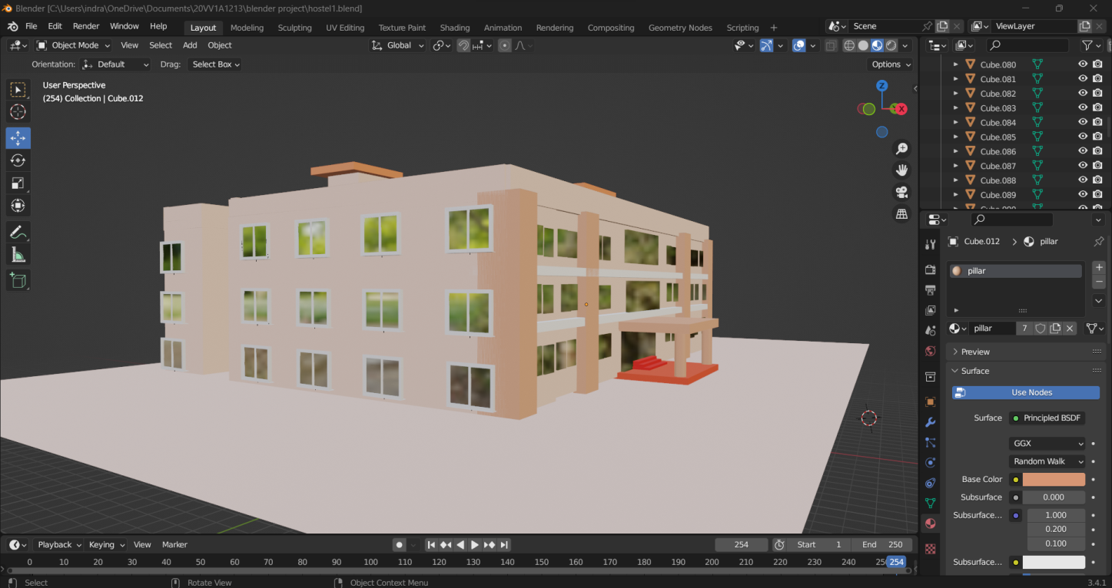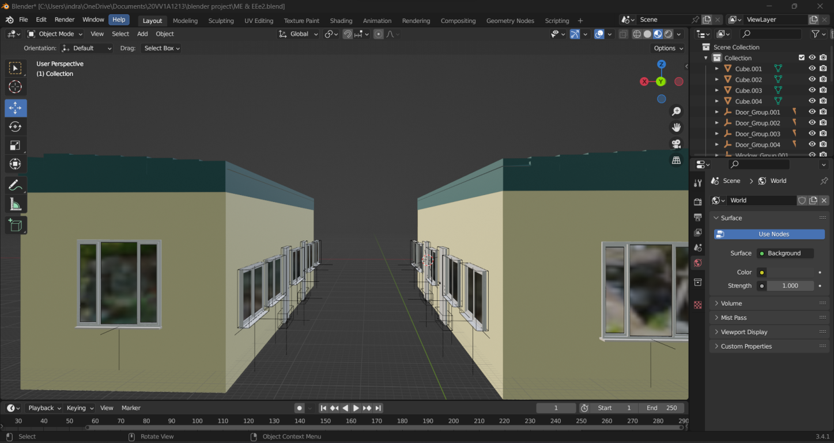

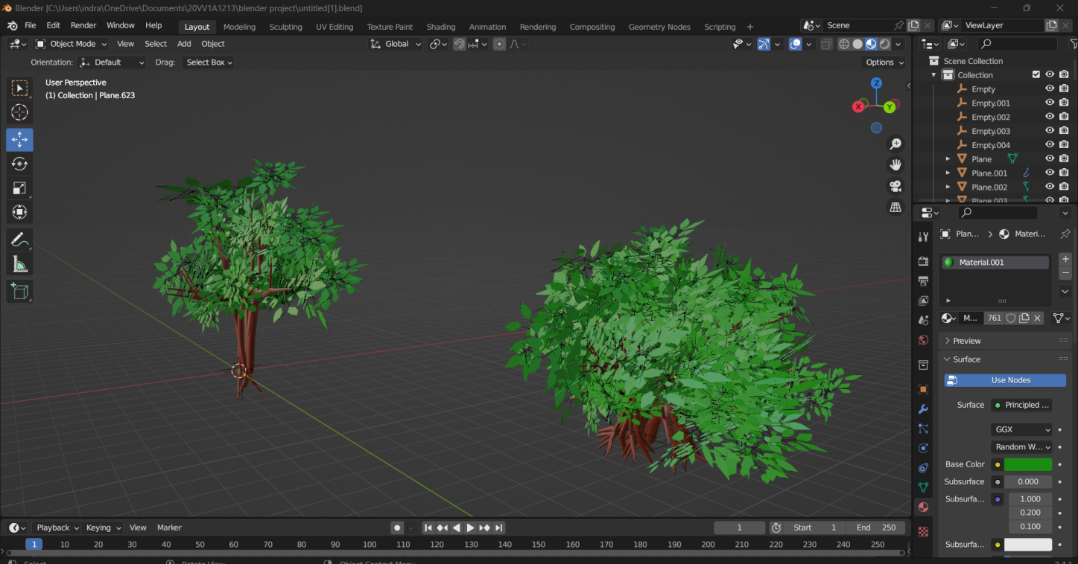

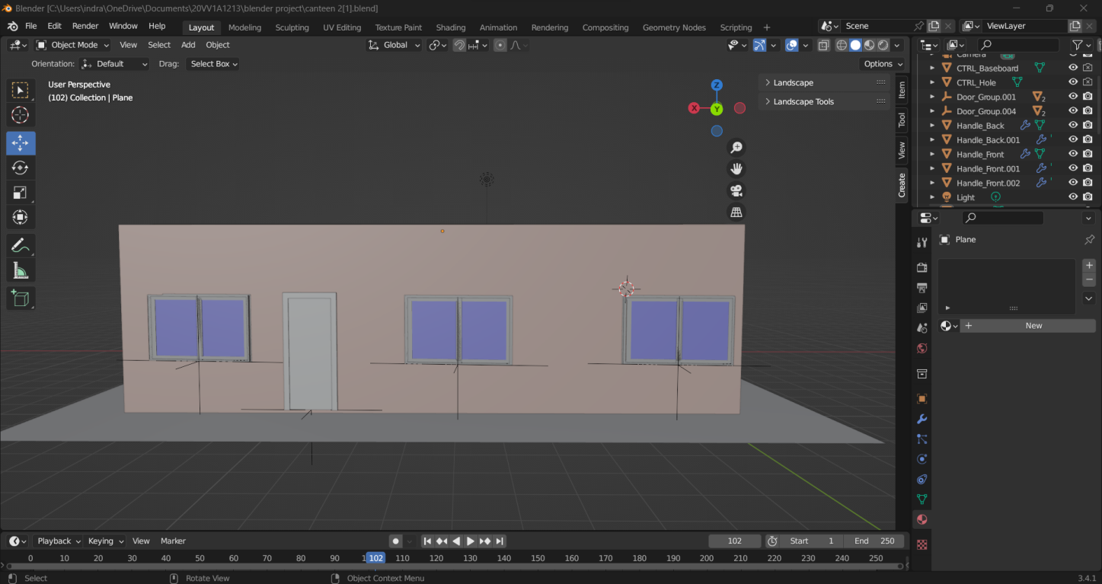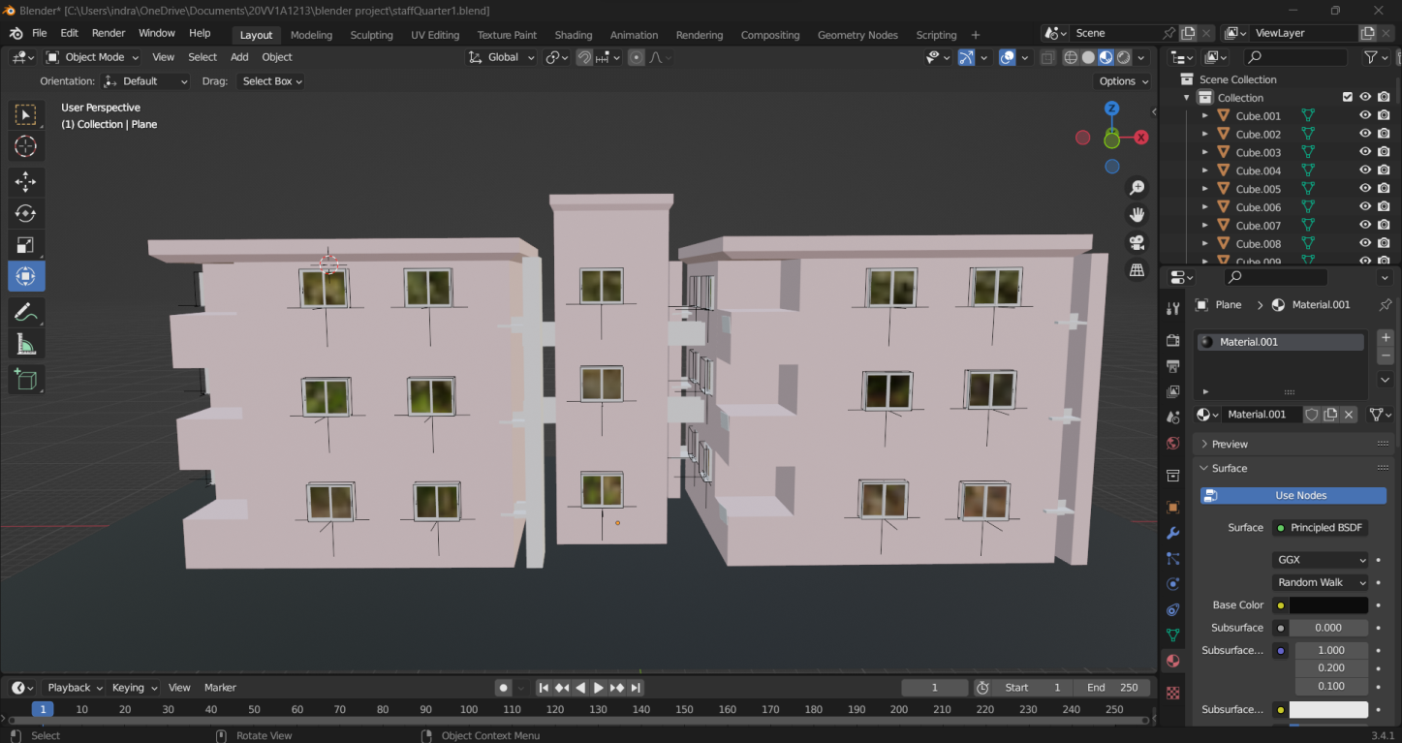

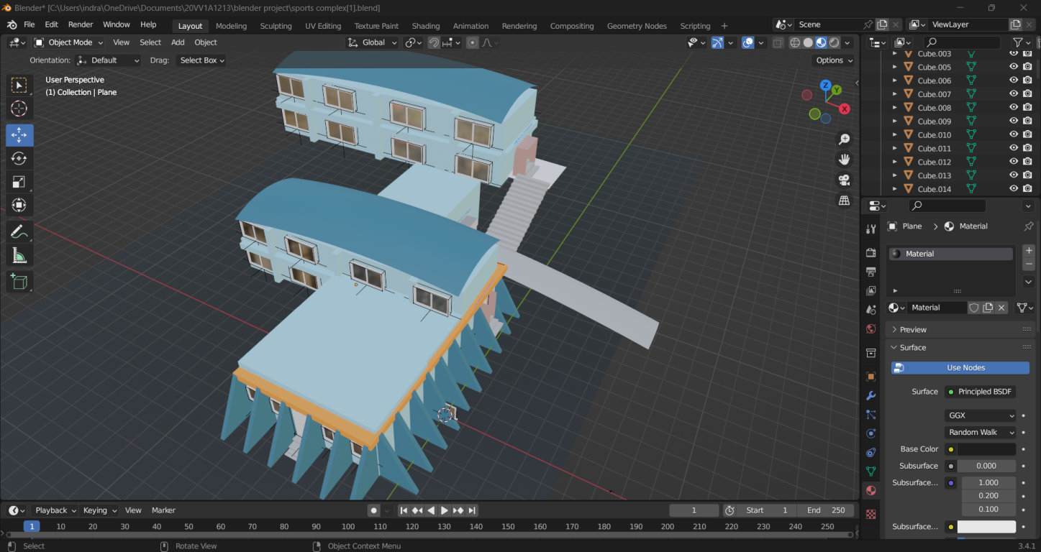

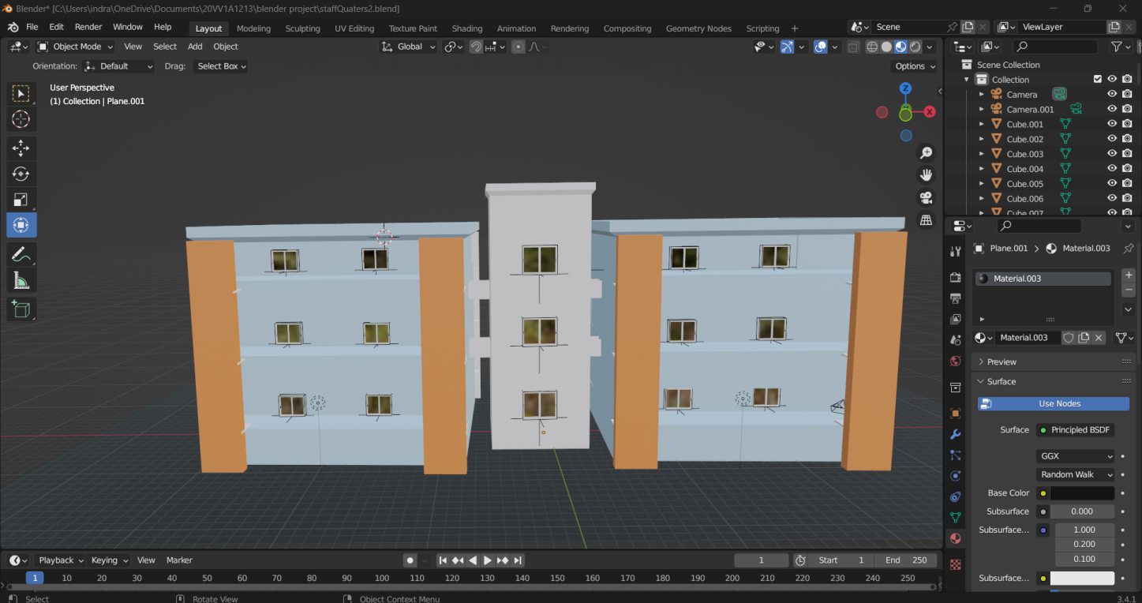

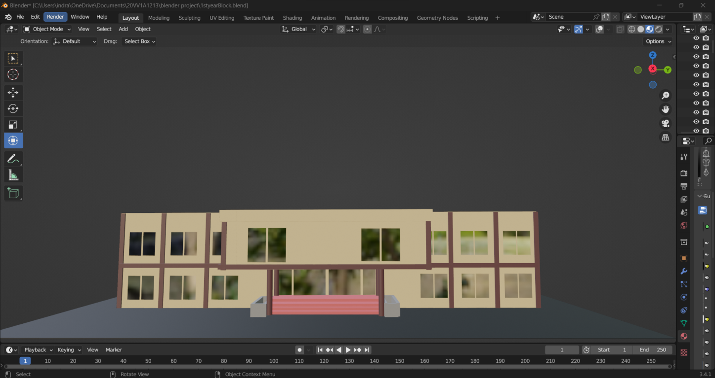

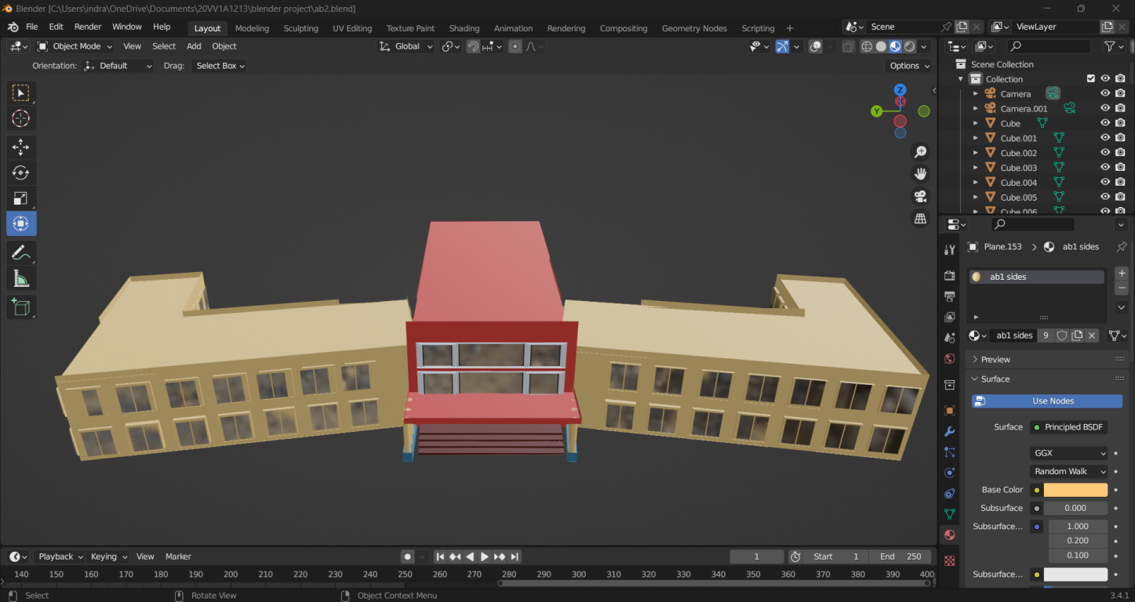

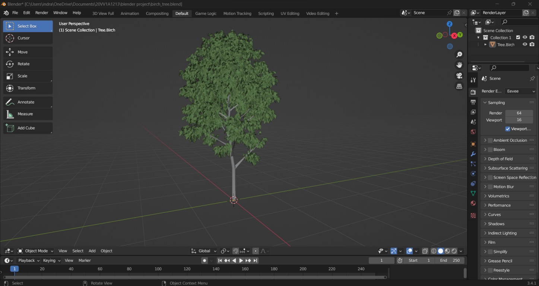

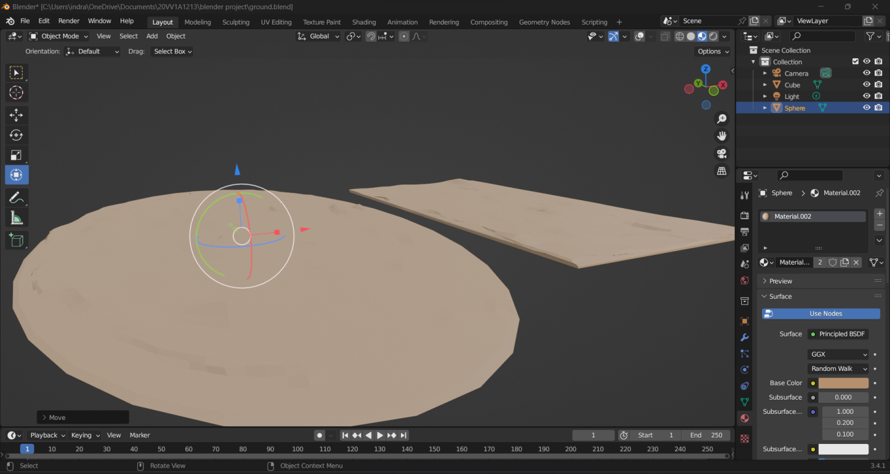

* Grooming them on to the landscape
* Adding further details
* Trees
* Roads
* Stairs
* Entrance

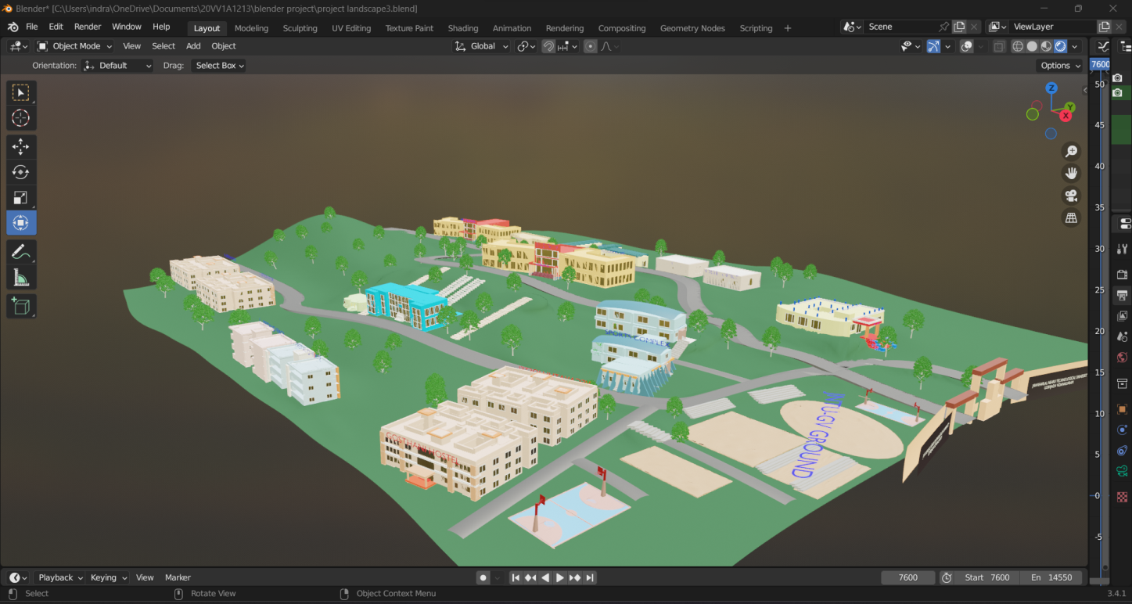

* Finally took a shot showing the arrangement usinf the process of rendering
* Showing every single detail present in the constructed anime of college landscape

**RENDERING PROCESS IN BLENDER**

**What is rendering in animation?**

Rendering is used in both 2D and 3D computer animation. It is the process of getting the final assembled animation scenes or pieces out of the computer in the format of a sequence of individual frames. The aim of rendering is to generate a series of individual pixel based frames or a video clip.

**Steps used in rendering process:**

* Press SHIFT A, it displays a dropdown menu in that select the camera option.
* After selecting the camera, adjust the camera settings by clicking ‘G’ and adjust the x and y axis and set ‘0’ for camera view.
* Go to the right of the blender and find out Render properties option.
* In Render properties,
* Select render engines and set as ‘cycles’.
* Select Denoise and keep a tick.
* Range of the max sample should be 100.
* Remove the tick from the Noise Threshold.
* Set the output properties and encoding properties.
* Press ctrl+F12 for automatic rendering process.
* After rendering process a video will be saved.